Tutorial for running the batch code

1. This .bat file aims at combining the motion correction process (by ImageJ) and stitch process (by Matlab) together to save some labor. (especially if more than one motion correction process is needed.
2. Prerequisite
   1. install Fiji (Fiji is just ImageJ). <https://fiji.sc/#download>

ImageJ itself does not support Python build-in module. I used a Jython code, thus Fiji is needed.

You do not need to install the turboreg (it is already in the Fiji package)

Install the Jython.jar (Fiji will ask you to install it the first time you run Jython code)

* 1. In Matlab, add the code directories into search path

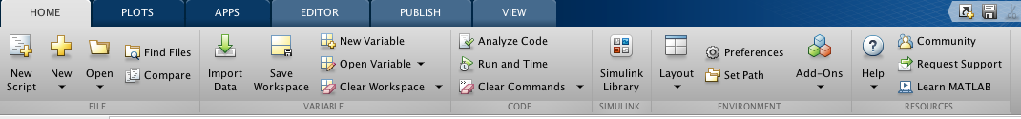

then use the “Add with subfolders..”. Make sure you add every needed code (The codes I provided and what we originally have (script..et. al.)

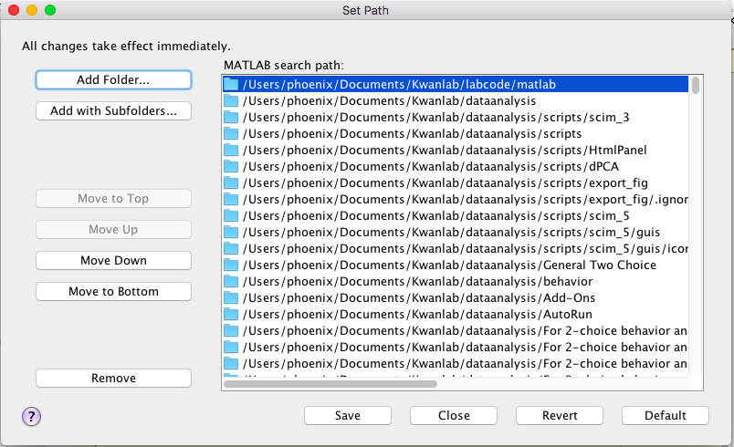

1. The analysis code

I modified the Stitch.m and batchTurboReg.ijm a little, so that they can be called directly by .bat files. Other important codes remain intact.

3.1 For batch(windows)/bash(max/linux):

analysis.bat / analysis.sh

3.2 For matlab

StitchforBash.m

3.3 For ImageJ

batchTurboReg_forPy.ijm

motionCorrection.py

1. Lines needed modify before running
   1. in analysis.bat:

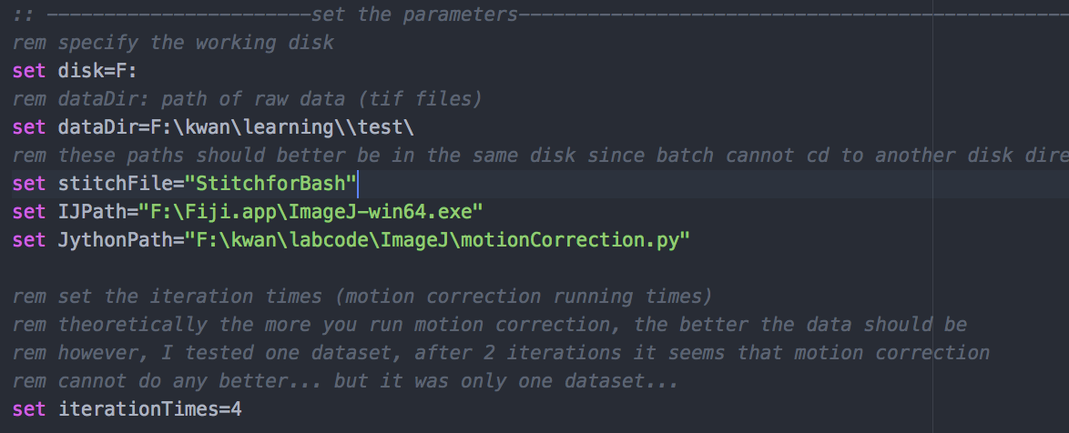

**disk**: the disk which contains the data (the codes and data should be under the same disk)

**dataDir**: the root path of your data (be careful with the ‘\’, windows may misread it as an escaping character, where you need add one more ‘\’to avoid that. This is true for any line which contains a path. That is why I don’t like windows.)

**IJPath**: the path of Fiji executable file

**JythonPath**: the path of the motionCorrection.py file

**iterationTimes**: the number of times of motion correction

* 1. in motionCorrection.py



**macroFileDir**: the path of the batchTurboReg_forPy.ijm

1. double click the analysis.bat, have a drink and it is done.